I added path of Telemetry Library Package in VS

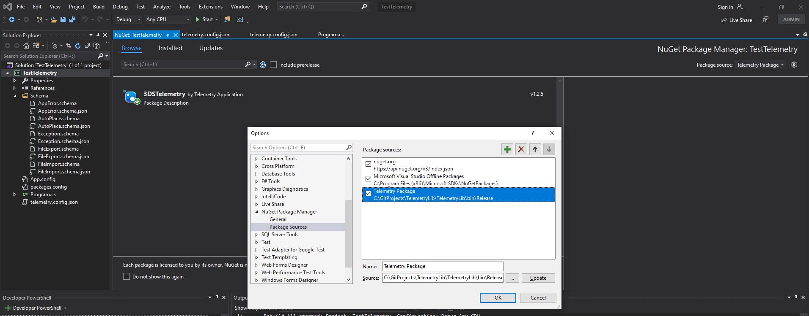

Next Selected Package Source as Telemetry Package in Top right corner and searched for 3DSTelemetry, which picked up correct package v. 1.2.5

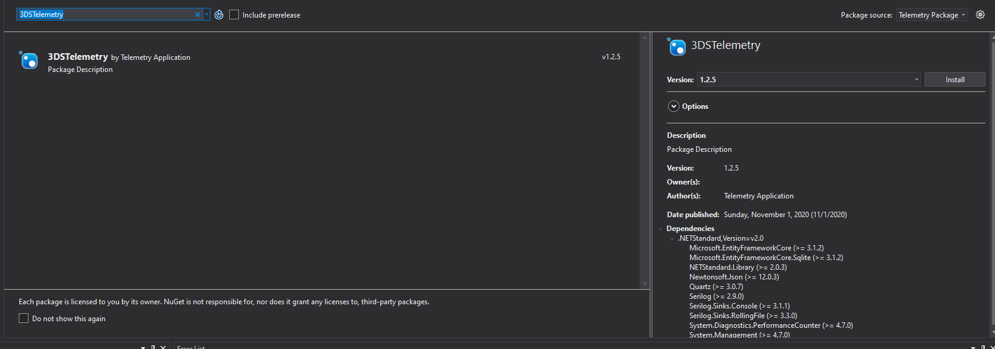

On clicking Install, VS should install all dependencies.

Telemetry Client –

Please include **telemetry.config.json** file in Client and select **Copy Always** option in **Copy To Output Direct**in the file **ory** Properties

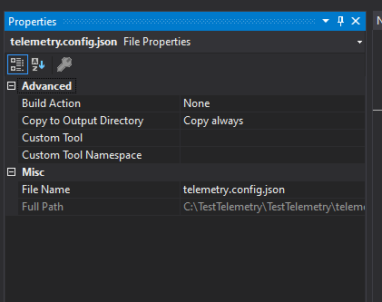

Similarly include JSON files under Schema folder. The Schema files are used if the option “**UseEventSchema”** in file **telemetry.config.json** contains value **True.**